Stepping Stones NI
39 Seymour Street
Lisburn
CO Antrim
BT27 4SX
Telephone: 02892 667124

54-56 Antrim St
Lisburn
Co Antrim
Telephone: 02892 666404

The Gatelodge
Church St
Newtownards
Co Down
Telephone: 02891 821395

Any Adults in a position of trust should never:
× talk to you privately on their own or in secret, or be ‘friends’ with you online
× arrange to meet you or ‘hang out’ with you alone or in private
× have a personal friendship or relationship with you
× ask you to keep secrets
× use alcohol, cigarettes, or illegal substances when at Stepping Stones NI, and they must not give them to you

HOW TO GET HELP
You can talk to an adult or your key worker at Stepping stones NI. Let them know you would like to talk about something you are worried about.
If it makes it easier for you, you can show them this card so they understand why you want to talk to them. You can also report something important or serious to them.
You can go to any adult you can trust e.g. your KEY WORKER or your EMPLOYMENT OFFICER at Stepping Stones NI.

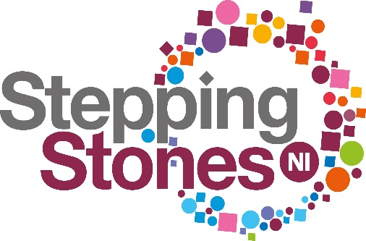

YOUR SAFEGUARDING POCKET GUIDE

Keep this somewhere safe and have it handy should you need it

Stepping Stones NI is a place for you to enjoy, achieve qualifications develop your work skills, have fun and make friends

WE WANT YOU TO FEEL HAPPY AND SAFE

It is wrong for ANYONE to hurt you or make you feel unsafe.
If they do it is not OK and it is not your fault.
At Stepping Stones NI you can SPEAK OUT if you have worries, and the adults at Stepping Stones NI should:
- Be kind

- Listen to you and take what you say seriously

- Help You

- Provide support.
It is s NOT OK for ANYONE to:
× physically hurt you on purpose
× Touch you in a way that makes you feel uncomfortable
× not give you what you need to be healthy and safe
× say things that make you feel bad about yourself
× Bully, shout at and/or tease you
× Do dangerous things that could put you at risk or make you feel unsafe
× Use rude words or comment on your appearance or body
REMEMBER

You have the right to be safe from harm and abuse.

It is NEVER your fault.

There are people who will listen to you and help you AT Stepping Stones NI e.g your Key Worker, Employment Officer.

Did you know?
Any adult aged 18 and over. Who works or volunteers with children and young adults is in a position of trust. They have a responsibility to keep you safe.

